

table of contents

1. About 2

2. Getting Started 2

3. Features 3

3.2. Adding 4

3.2.1. Adding a person: ADD 4

3.2.2. Adding an event: ADDE 4

3.3. Listing 4

3.3.1. Listing all persons: LIST 4

3.3.2. Adding an event: LISTE 5

3.4. Sorting all persons and events: sort 5

3.5. Editing 6

3.5.1. Editing a person: EDIT 6

3.5.2. Editing an event: EDITE 6

3.6. Locating persons by name: find 7

3.7. Deleting 8

3.7.1. Deleting a person: Delete 8

3.7.2. Deleting an event: DeleteE 9

3.8. Connecting a person to an event: join 10

3.9. Disconnecting a person to an event: disjoin 10

3.10. Showing all participants of an event: showP 11

3.11. Selecting all events which a person joins: selectE 12

3.12. Listing entered commands: history 13

3.13. Undoing previous command: undo 13

3.14. Redoing the previously undone command: redo 15

3.15. Clearing all entries: clear 17

3.16. Viewing help: help 18

3.17. Exiting the program: exit 18

3.18. Saving the data 18

**4. Features Coming in V2.0 18**

**5. Command Summary 18**

**6. FAQ 19**

1. About

Sometimes do you feel that you have too many contacts and cannot manage them clearly? Or sometimes you have too many events and cannot remember all the participants involved in those events? Do not worry! Planno can help you to solve these problems!

Planno is a assistant that helps you to manage your contacts and events. It will tell you who are the participants according to the event. Moreover, it can tell you your contacts join in which event.

Planno is more powerful than the other contact managers or task managers and it combines these two types of application into one. Furthermore, Planno is very simple to use and you only need to type some short commands. There are no click buttons and the program will only execute the command according to what you type.

This user guide will give you a step by step instruction on how you can start up and use Planno.

# 2. Getting Started

Before we start our journey on Planno, here are some simple steps for you to launch this application:

1. Ensure you have Java version 1.8.0_60 or later installed in your Computer.

|  |  |
| --- | --- |
| NOTE | Having any Java 8 version is not enough. This app will not work with earlier versions of Java 8. |

2. Download the latest addressbook.jar [here](https://github.com/CS2103AUG2017-W14-B4/main/releases).

3. Copy the file to the folder you want to use as the home folder for your Address Book.

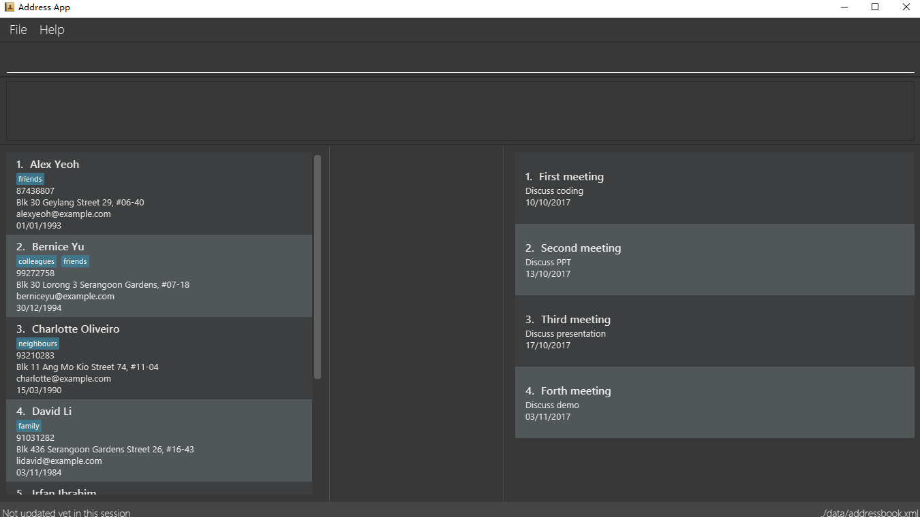4. Double-click the file to start the app. The GUI should appear in a few seconds, as shown in the figure below. Note that you will see some initial data if it is the first time to use.

*Figure 2: GUI*

5. Type the command in the command box and press Enter to execute it.  
e.g. typing Enter and pressing Enter will open the help window.

6. Try some of these examples:

* ***list***: lists all contacts
* *addn/John Doe p/98765432 e/johnd@example.com a/John street, block 123, #01-01*: adds a contact named John Doe to the Address Book.
* *delete 3*: deletes the 3rd contact shown in the current list
* *exit*: exits the app

|  |  |
| --- | --- |
| NOTE | For the details of each command, please refer to Features section. |

Congratulations! If you can run Planno without any trouble, you can start trying this application. Otherwise, Please refer to FAQ and solve your problems.

# 3. Features

## 3.1. General

### Command Format

* Words in UPPER_CASE are the parameters to be supplied by the user

e.g. in *add n/NAME, NAME* is a parameter which can be used as *add n/John Doe*.

* Items in square brackets are optional

e.g. *n/NAME [t/TAG]* can be used *as n/John Doe t/friend* or as *n/John Doe.*

* Items with **…​** after them can be used multiple times including zero times

e.g. *[t/TAG] …* can be used as (i.e. 0 times), *t/friend, t/friend t/family* etc.

* Parameters can be in any order

e.g. if the command specifies *n/NAME p/PHONE_NUMBER*, then *p/PHONE_NUMBER n/NAME* is also acceptable.

* Command key wards are case sensitive.

e.g. only *help* means help command, while *HELP, Help* and *hElP*are not.

### Command Format

* 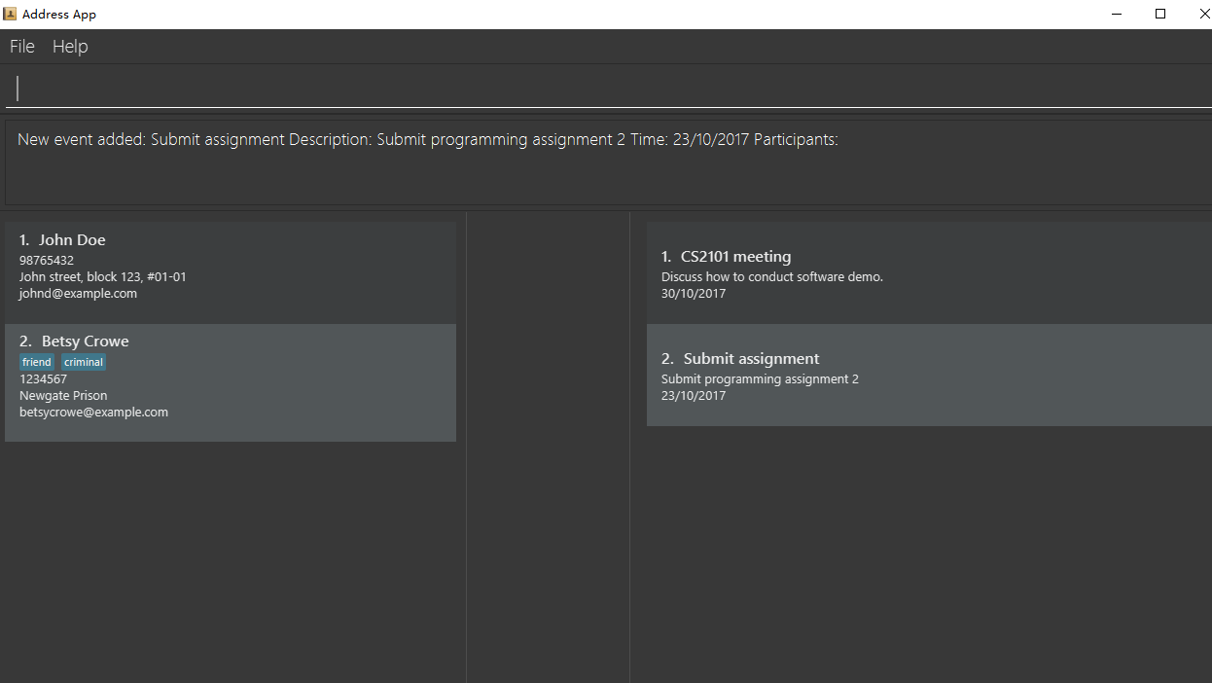Unless otherwise stated, all the example screenshots are operated based on the following stage:

*Figure 3.1: base stage*

## 3.2. Adding

### 3.2.1. Adding a person: *add*

You can use it to add a person to the address book  
Format: **add n/NAME p/PHONE_NUMBER e/EMAIL a/ADDRESS [t/TAG] …​**

* A person can have any number of tags (including 0)

Examples:

* **add n/John Doe p/98765432 e/johnd@example.com a/John street, block 123, #01-01**
* **add n/Betsy Crowe t/friend e/betsycrowe@example.com a/Newgate Prison p/1234567 t/criminal**

### 3.2.2. Adding an event: *addE*

You can use it to add an event to the event list  
Format: **addE en/EVENT_NAME ed/EVENT_DESCRIPTION et/EVENT_TIME**

* You need to type EVENT_TIME as a date format DD/MM/YYYY (Use "/" instead of "-")

Examples:

* **addE en/CS2101 meeting ed/Discuss how to conduct software demo. et/30/10/2017**
* **addE en/Submit assignment ed/Submit programming assignment 2 et/23/10/2017**

You will see the following after typing 4 above example add command to an empty address book and an empty event list:

*Figure 3.2: add command result*

## 3.3. Listing

### 3.3.1. Listing all persons: *list*

Shows a list of all persons in the address book.  
Format & Example: *list*

### 3.3.2. Listing all events: *listE*

Shows a list of all events in the event list.  
Format & Example: *listE*

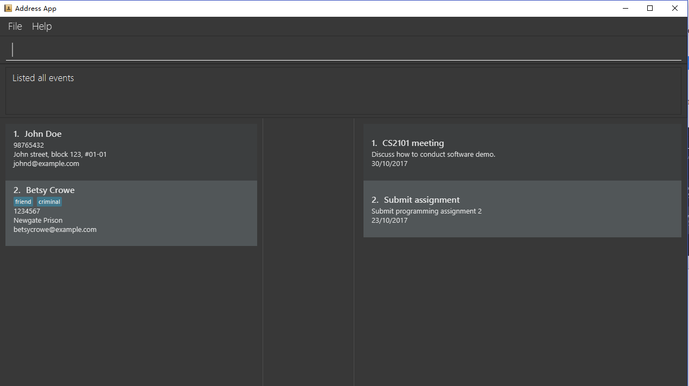You will see the following after typing 2 above example list command:

*Figure 3.3: list command result*

*Figure 3.4: sort command result*

## UG sort3.4. Sorting all persons and events: sort

The figure above shows the result after typing sort command:

You can use sort command to view a list of sorted persons in the address book according to the alphabetical order of their names, and a list of sorted events in the event list according to the event time.  
Format & Example: *sort*

## 3.5. Editing

### 3.5.1. Editing a person:*edit*

You can use it to edits an existing person in the address book.  
Format: e**dit INDEX [n/NAME] [p/PHONE] [e/EMAIL] [a/ADDRESS] [t/TAG] …​**

* Edits the person at the specified **INDEX**. The index refers to the index number shown in the last person listing. The index **must be a positive integer** 1, 2, 3, …​
* At least one of the optional fields must be provided.
* Existing values will be updated to the input values.
* When editing tags, the existing tags of the person will be removed i.e adding of tags is not cumulative.
* You can remove all the person’s tags by typing **t/**without specifying any tags after it.

Examples:

* **edit 1 p/91234567 e/johndoe@example.com**  
  Edits the phone number and email address of the 1st person to be 91234567 and johndoe@example.com respectively.
* **edit 2 n/Betsy Crower t/**  
  Edits the name of the 2nd person to be Betsy Crower and clears all existing tags.

### 3.5.2. Editing an event: *editE*

You can use it to edits an existing event in the event list.  
Format: *editE INDEX [en/NAME] [ed/DESCRIPTION] [et/TIME]*

* Edits the event at the specified **INDEX.** The index refers to the index number shown in the last event listing. The index **must be a positive integer**1, 2, 3, …​
* At least one of the optional fields must be provided.
* Existing values will be updated to the input values.
* You need to type **TIME** as a date format DD/MM/YYYY.

Examples:

* **editE 1 en/CS2103 project meeting et/03/11/2017**Edits the event name and event time of 1st event to be CS2103 project meeting and /03/11/2017 respectively.
* **editE 2 ed/Submit handwritten assignment**  
  Edits the event description of 2nd event to be Submit handwritten assignment

You will see the following after typing 4 above edit command:

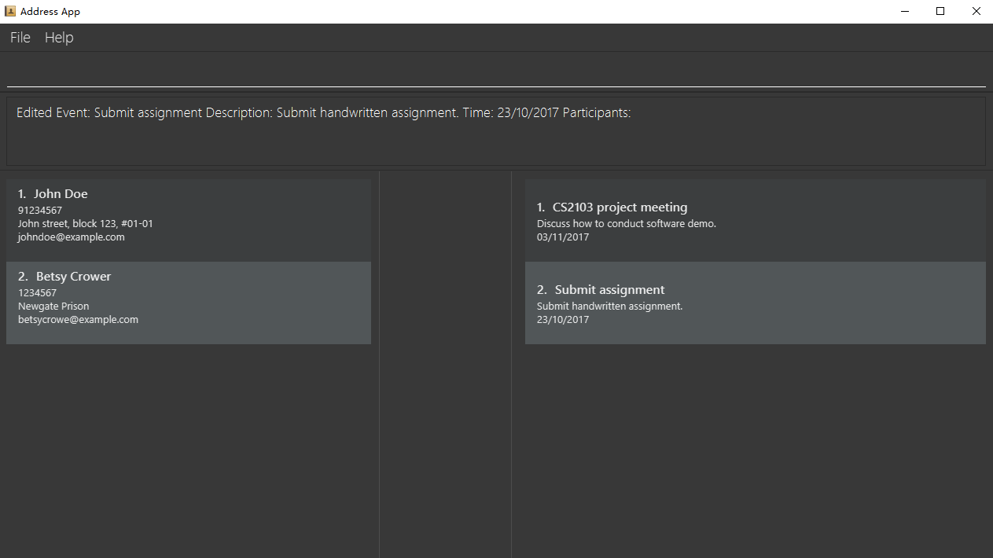

*Figure 3.5: edit command result*

## 3.6. Locating persons by name: find

Finds persons whose names contain any of the given keywords.  
Finds persons who have any of the given tags.  
Format: *find KEYWORD [MORE_KEYWORDS]*

* The search is case insensitive. e.g. **hans** will match **Hans**
* The order of the keywords does not matter. e.g. **Hans Bo** will match **Bo Hans**
* The name and tag names searched.
* Tags should be indicated by prefix **t/**
* Only full words will be matched e.g. **Han**will not match **Hans**
* Persons matching at least one keyword will be returned (i.e. **OR** search). e.g. **Hans Bo** will return **Hans Gruber, Bo Yang**

Examples:

* **find John**  
  Returns john and John Doe
* **find Betsy Tim John**  
  Returns any person having names Betsy, Tim, or John
* **find t/friends**

Returns any person having tag friends

* **find t/colleagues John**

Returns any person having name John or having tag colleagues

You will see the following after typing **find John:**

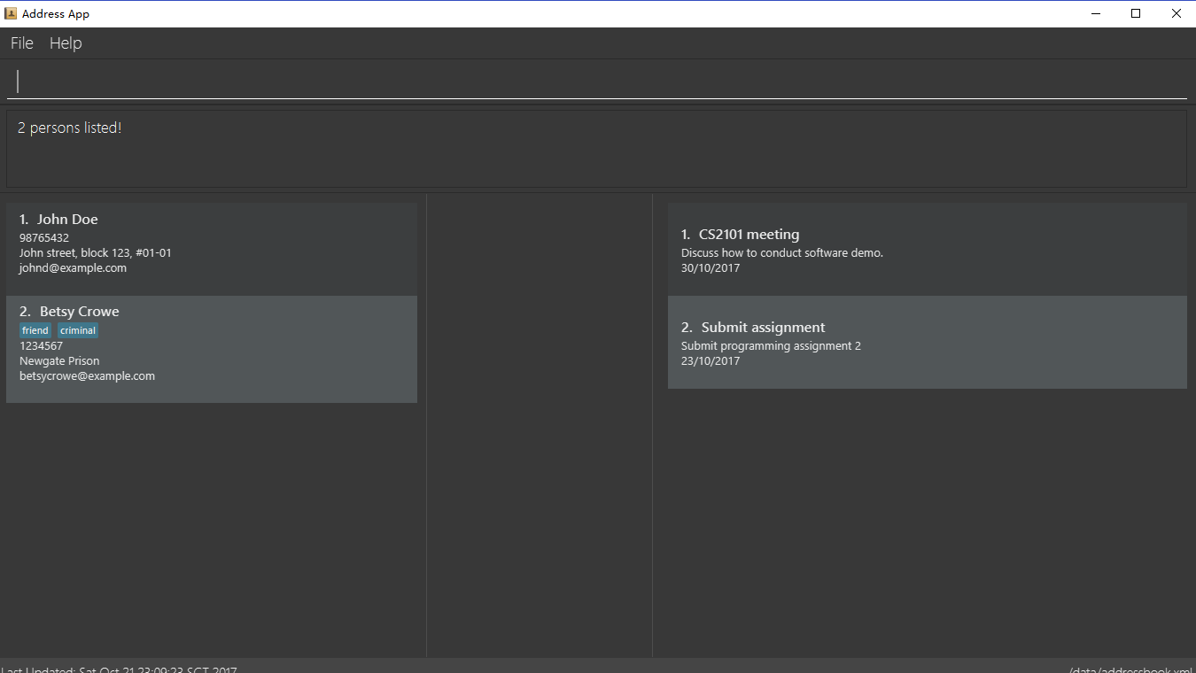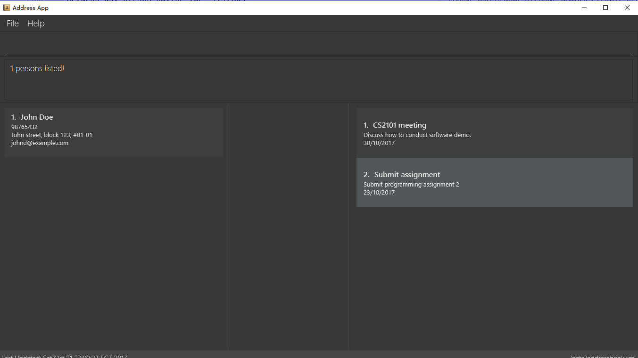Subsequently, you will see the following after typing **find Betsy john**:

*Figure 3.6.2: find command result 2*

*Figure 3.6.1: find command result 1*

## 3.7. Deleting

### 3.7.1. Deleting a person: *delete*

Deletes the specified person from the address book.  
Format: *delete INDEX*

* Deletes the person at the specified **INDEX**.
* The index refers to the index number shown in the most recent listing.
* The index **must be a positive integer** 1, 2, 3, …​

Examples:

* **list  
  delete 2**  
  Deletes the 2nd person in the address book.
* **find Betsy  
  delete 1**  
  Deletes the 1st person in the results of the find command.

### 3.7.2. Deleting an event: *deleteE*

Deletes the specified event from the event list.  
Format: *deleteE INDEX*

* Deletes the event at the specified **INDEX.**
* The index refers to the index number shown in the most recent event listing.
* The index **must be a positive integer** 1, 2, 3, …​

Example:

* **listE  
  deleteE 2**  
  Deletes the 2nd event in the event list.

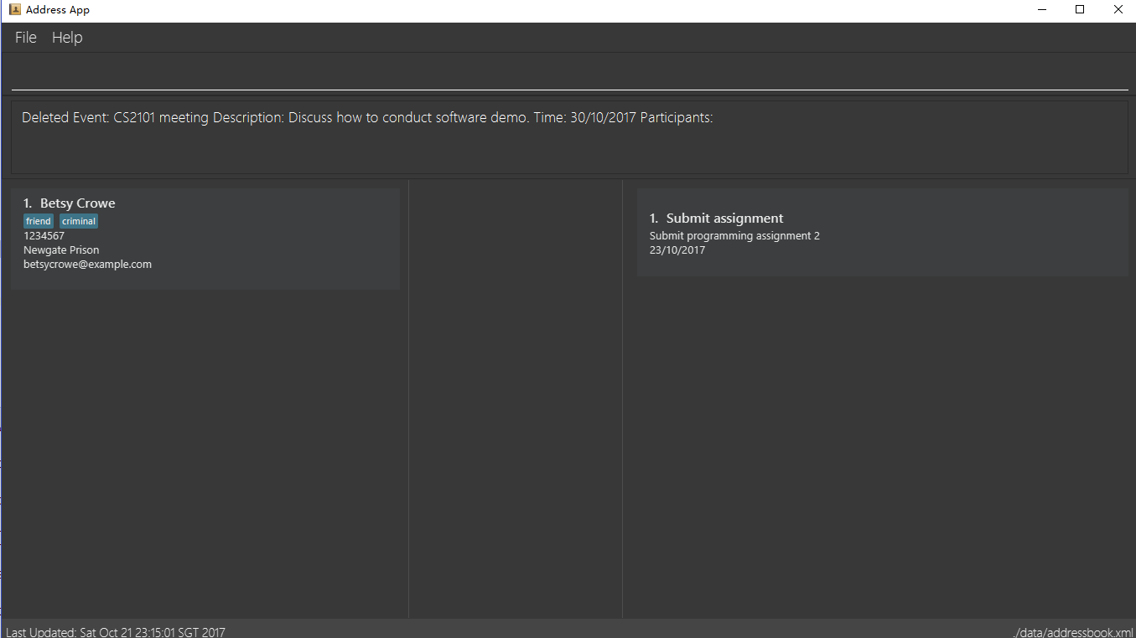You will see the following after typing **delete 1** and **deleteE 1**:

*Figure 3.7: delete command result*

## 3.8. Connecting a person to an event: join

You can use it to show a person is involved in an event.  
Format: *join p/INDEX_P e/INDEX_E*

* The person at position **INDEX_P** will be involved in the event at position **INDEX_E**.
* The index **must be a positive integer** 1, 2, 3 …
* Make sure you type the prefixes **p/**and **e/** to distinguish person index and event index.

Example:

* **list  
  listE  
  join p/2 e/1**The 2nd person in the address book will be involved in the 1st event in the event list.

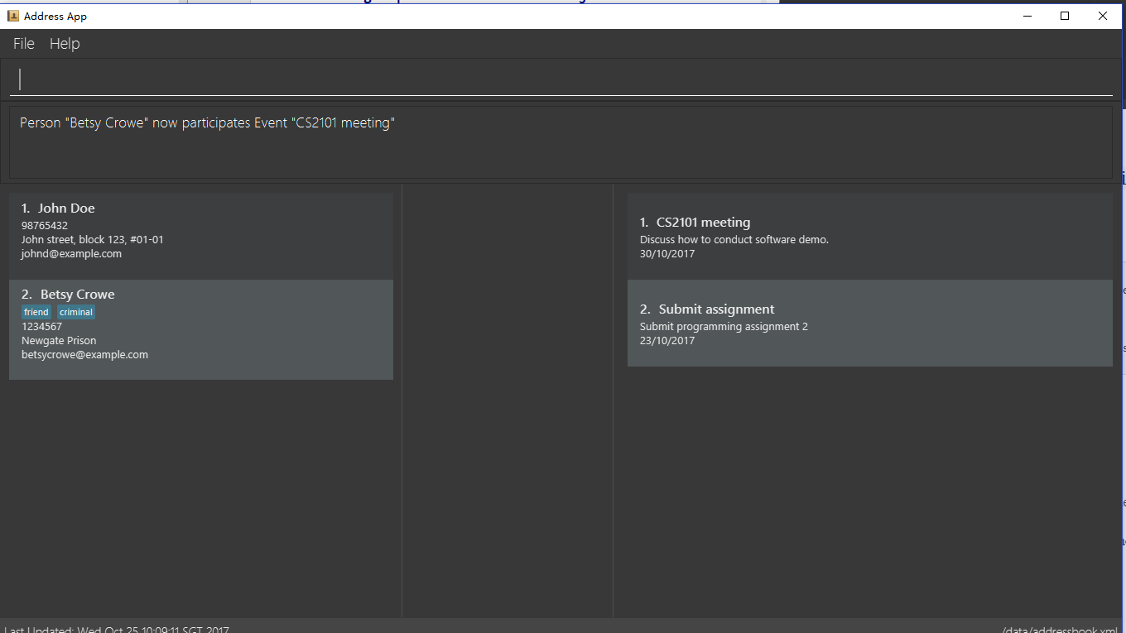This command only displays a successful message. You cannot see explicit change in the panel.  
You will see the following after typing above commands:

*Figure 3.8: join result*

## 3.9. Disconnecting a person to an event: disjoin

You can use it to show a person is not involved in an event any more.  
Format: *disjoin p/INDEX_P e/INDEX_E*

* The person at position **INDEX_P** will be involved in the event at position **INDEX_E**.
* The index **must be a positive integer** 1, 2, 3 …
* Make sure you type the prefixes **p/** and **e/** to distinguish person index and event index.
* This person **must be already involved in this event**.

Example:  
Assuming you have typed **join p/2 e/1** before this example.

* **list  
  listE  
  disjoin p/2 e/1**The 2nd person in the address book will not be involved in the 1st event in the event list any more.

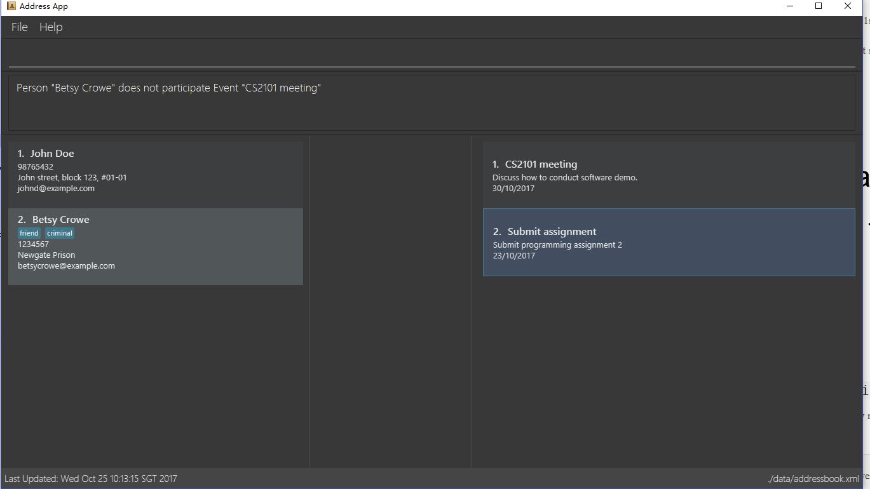This command only displays a successful message. You cannot see explicit change in the panel.  
You will see the following after typing above commands:

*Figure 3.9: disjoin result*

## 3.10. Showing all participants of an event: showP

You can use it to view all persons who join a certain event.  
Format: *showP EVENT_INDEX*

* Shows all persons who join the event at the specified **EVENT_INDEX**.
* The index refers to the index number shown in the most recent event listing.
* The index **must be a positive integer** 1, 2, 3 …

Example:  
Assuming you have typed **join p/2 e/1** before this example.

* **listE  
  showP 1**Shows all persons who are involved in the 1st event of event list.

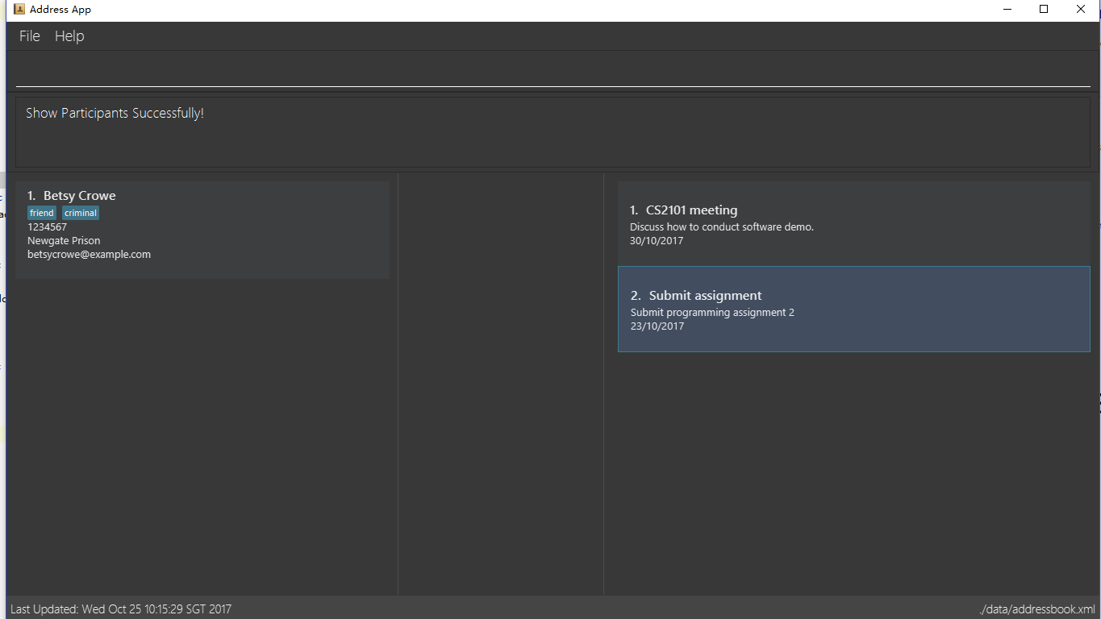You will see the following after typing above commands:

*Figure 3.10: show persons result*

## 3.11. Selecting all events which a person joins: selectE

You can use it to view all events which a certain person joins.  
Format: *selectE PERSON_INDEX*

* Shows all events which the person at the specified **PERSON_INDEX** joins.
* The index refers to the index number shown in the most recent person listing.
* The index **must be a positive integer** 1, 2, 3 …

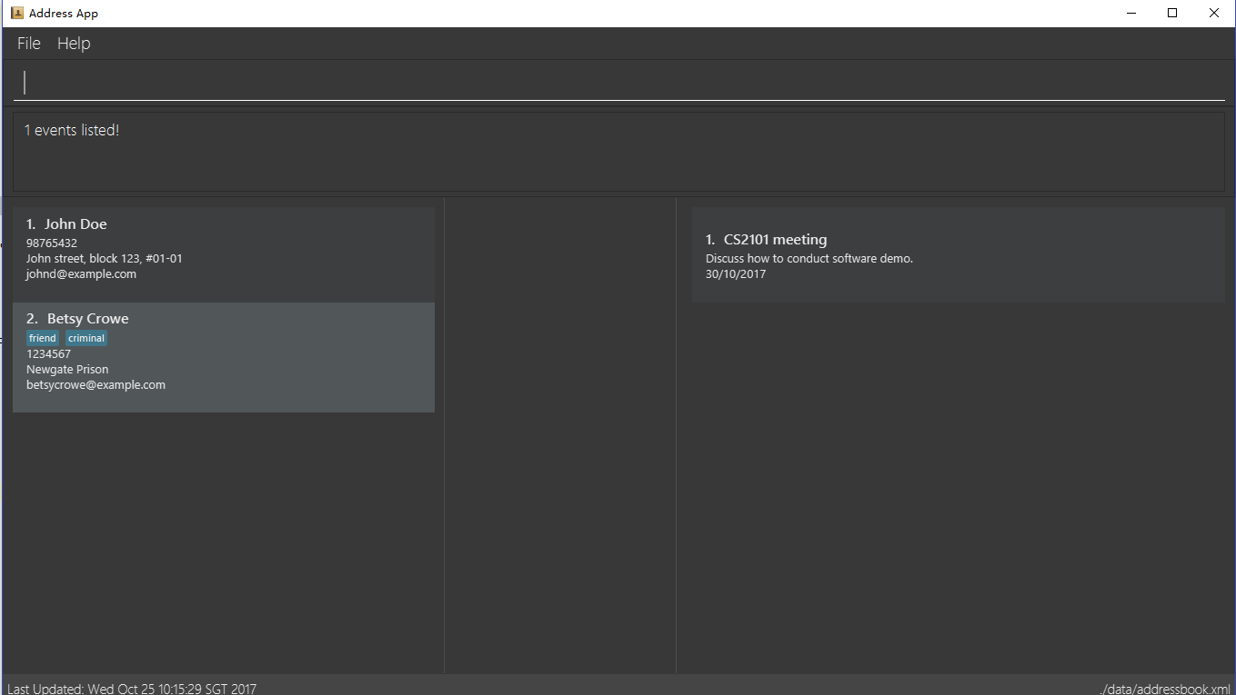Examples:  
Assuming you have typed **join p/2 e/1** before this example. You will see the following after typing **list** and **selectE 2:**

*Figure 3.11: select events result*

* **list  
  selectE 2**  
  Shows all events which the 2nd person in the address book joins.
* **find Betsy  
  selectE 1**Shows all events which the 1st person in the results of the find command joins.

## 3.12. Listing entered commands : history

Lists all the commands that you have entered in reverse chronological order.  
Format & Example: *history*

* Pressing the ↑ and ↓ arrows will display the previous and next input respectively in the command box.

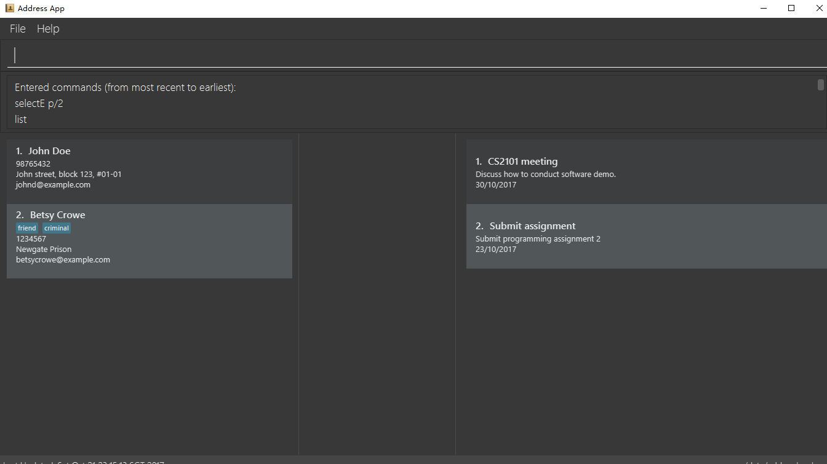You will see the following after typing history command:

*Figure 3.12: history result*

## 3.13. Undoing previous command: undo

Restores the address book or event list to the state before the previous *undoable* command was executed.  
Format: *undo*

* Undoable commands: those commands that modify the content in address book or event list (**add, delete, edit, clear, join and disjoin**).

Examples:

* **delete 1  
  list  
  undo** (reverses the delete 1 command)
* **select 1  
  list  
  undo**  
  undo command fails as there are no undoable commands executed previously.
* **delete 1  
  clear  
  undo** (reverses the clear command)  
  **undo** (reverses the delete 1 command)

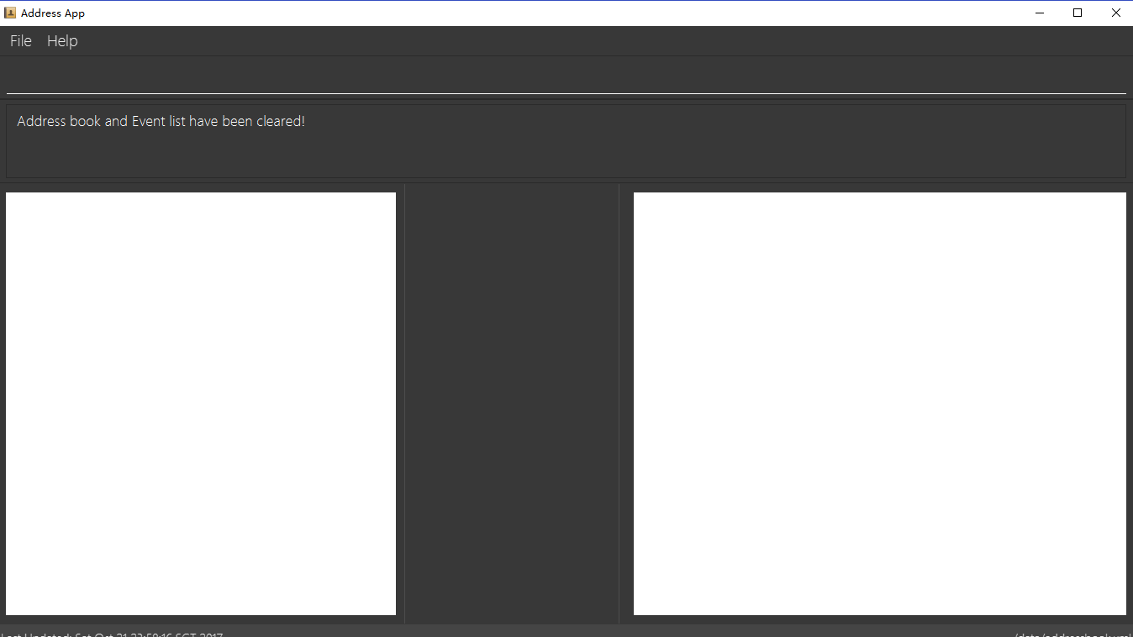You will see the following after typing **delete 1** and **clear**:

*Figure 3.13.1: before undo*

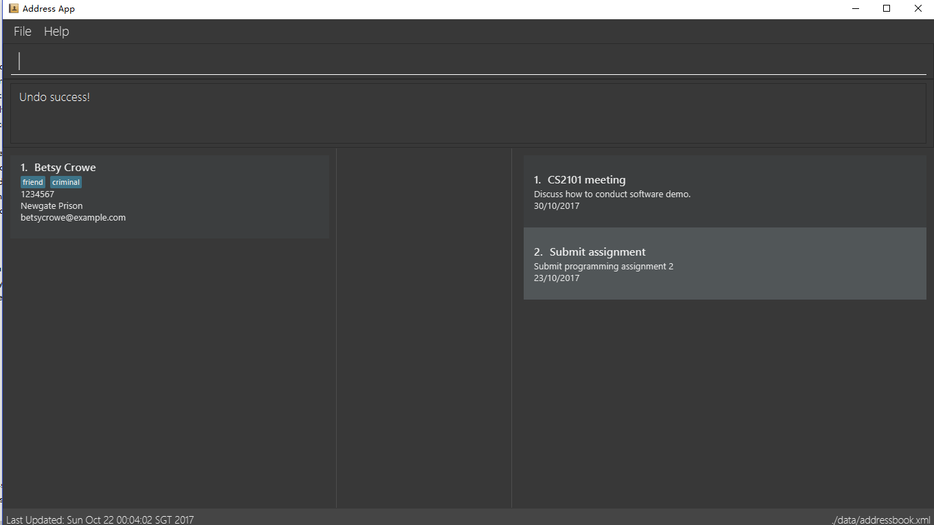You will see the following after typing **undo**:

*Figure 3.13.2: undo once*

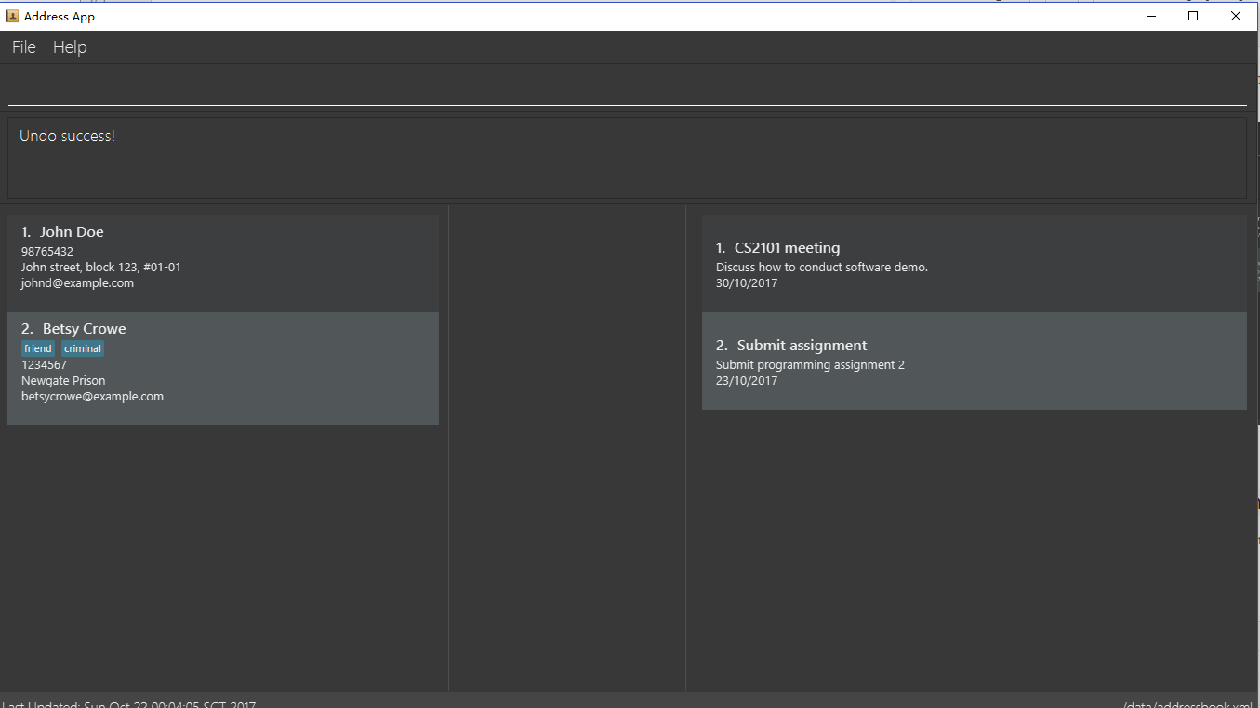You will see the following after typing **undo** again:

*Figure 3.13.3: undo twice*

## 3.14. Redoing the previously undone command: redo

Reverses the most recent **undo** command.  
Format: *redo*

Examples:

* **delete 1  
  undo** (reverses the delete 1 command)  
  **redo** (reapplies the delete 1 command)
* **delete 1  
  redo**  
  The redo command fails as there are no undo commands executed previously.
* **delete 1  
  clear  
  undo** (reverses the clear command)  
  **undo**(reverses the delete 1 command)  
  **redo** (reapplies the delete 1 command)  
  **redo** (reapplies the clear command)

You will see the following after typing **delete 1**, **clear**, **undo** and **undo**:

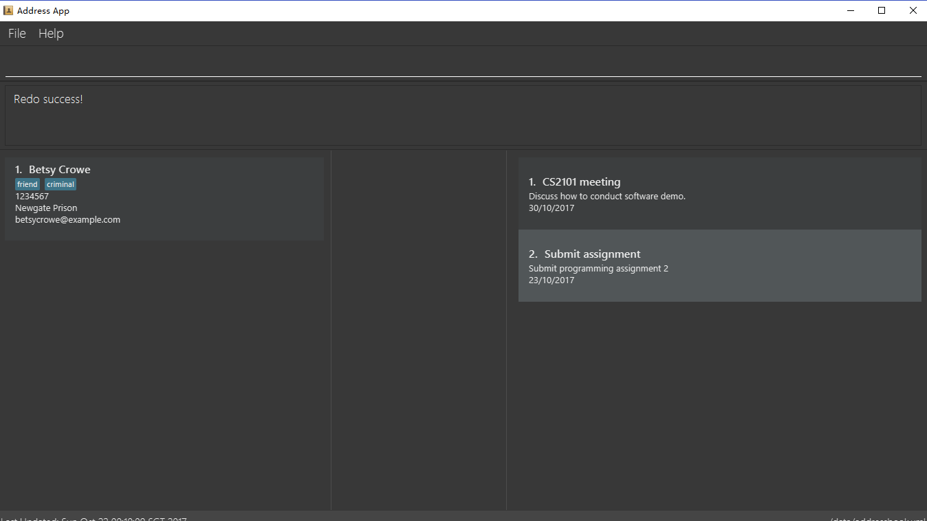You will see the following after typing **redo:**

*Figure 3.14.1: before redo*

*Figure 3.14.2: redo once*

You will see the following after typing **redo** again:

## UG redo23.15. Clearing all entries: clear

*Figure 3.14.2: redo twice*

Clears all entries from the address book and the event list.  
Format & Example: *clear*

* You will clear both persons and events by typing this command.

You will see the following after clear command:

*Figure 3.15: clear result*

## 3.16. Viewing help: help

Format & Example: *help*  
The help window is same as this user guide.

## 3.17. Exiting the program: exit

Exits the program.  
Format & Example:*exit*

## 3.18. Saving the data

Address book data are saved in the hard disk automatically after any command that changes the data.  
There is no need to save manually.

# 4. Features coming in V2.0

### The following features are coming for version 2.0

Users can connect this app with several social media platforms, and import data from them.

Users can send messages through this app.

Users can be alarmed when an event is going to take place.

Users can design their own GUI appearances (e.g colour, font).

# 5. Command Summary

* **Adding an event:** *addE en/EVENT_NAME ed/EVENT_DESCRIPTION et/EVENTTIME*e.g. adde en/Project Meeting ed/Project meeting with CS2103 Team Members et/20/10/2017
* **Adding a person***: add n/NAME p/PHONE_NUMBER e/EMAIL a/ADDRESS [t/TAG] …​*e.g. add n/James Ho p/22224444 e/jamesho@example.com a/123, Clementi Rd, 1234665 t/friend t/colleague
* **Clear**: *clear*
* **Deleting an event**: *delete INDEX*  
  e.g. deleteE 5
* **Deleting a person**: *delete INDEX*  
  e.g. delete 3
* **Disjoining an event**: *disjoin p/PERSON_INDEX e/EVENT_INDEX*  
  e.g. disjoin p/4 e/6
* **Editing an event**: *editE INDEX [en/NAME] [ed/DESCRIPTION] [et/TIME]*  
  e.g. edit 1 en/Lunch ed/Lunch with Albert at Bishan
* **Editing a person**: *edit INDEX [n/NAME] [p/PHONE_NUMBER] [e/EMAIL] [a/ADDRESS] [t/TAG]…​*e.g. edit 2 n/James Lee e/jameslee@example.com
* **Find**: *find KEYWORD [MORE_KEYWORDS]*  
  e.g. find James Jake e.g. find t/friends e.g. find t/neighbors alex
* **Help**: *help*
* **History**: *history*
* **Joining an event:** *join p/PERSON_INDEX e/EVENT_INDEX*  
  e.g. join p/3 e/1
* **Listing every person**: *list*
* **Listing every event**: *listE*
* **Redo**: *redo*
* **Selecting every event a person has joined**: *selectE p/INDEX*  
  e.g. selectE p/1
* **Showing every participant in an event**: *showP EVENT_INDEX*e.g. showP 2
* **Sort**: *sort*
* **Undo**: *undo*

# 6. FAQ

**Q**: Do I need to install anything else other than Java 1.8.0_60?  
**A**: No. Planno only needs Java 1.8.0_60 or any later versions to work.

**Q**: How do i run/open Planno with the jar file?  
**A**: Double click the jar file to run Planno.

**Q**: Can I run Planno with a older version of Java?  
**A**: No. You will not be able to run Planno.

**Q**: How do I transfer my data to another Computer?  
**A**: Install the app in the other computer and overwrite the empty data file it creates with the file that contains the data of your previous Address Book folder.